Outlook Configuration

Please reference this guide for setting up your Clinton Foundation email account in Outlook 2007.

- Go to Start -> Control Panel. If the Mail icon does not appear, click “Small Icons”.

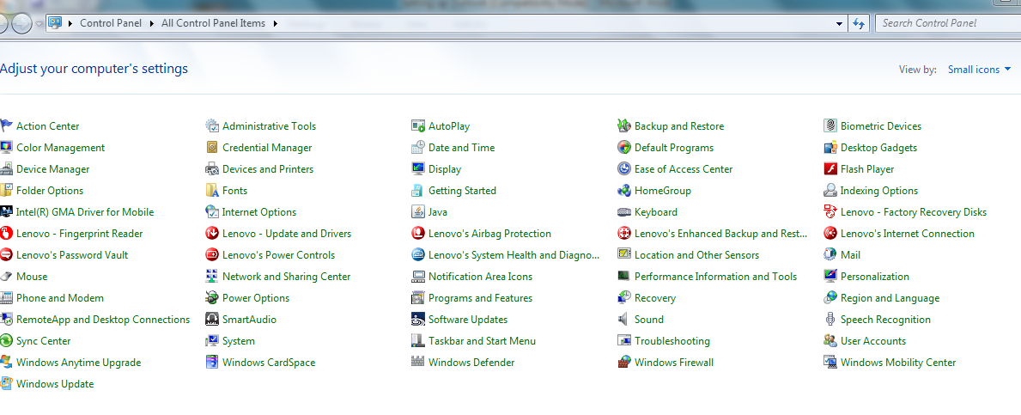

- Open the ‘Mail’ icon.

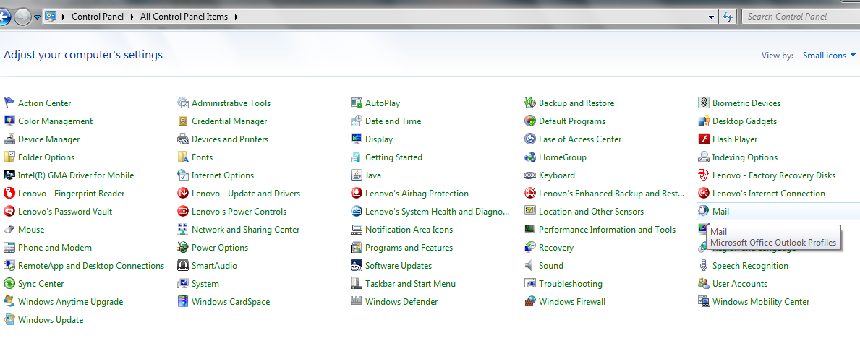

Then click on “ show Profiles..”

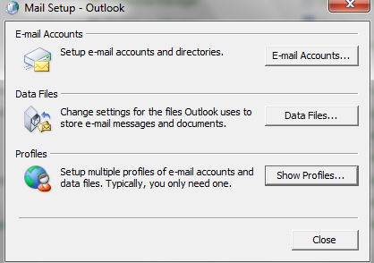

- Choose the radio button ‘Click on . Then click ‘Add…’

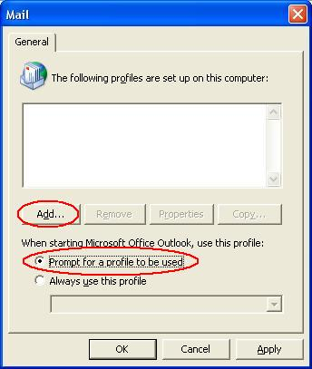

- In the next window check the box ‘Manually configure server settings or additional server types’ and hit ‘Next’.

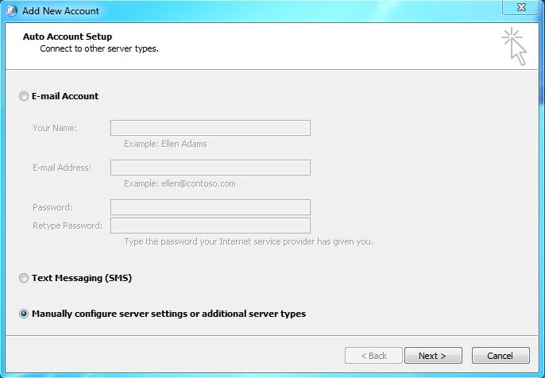

- Choose Microsoft Exchange and hit ‘Next’.

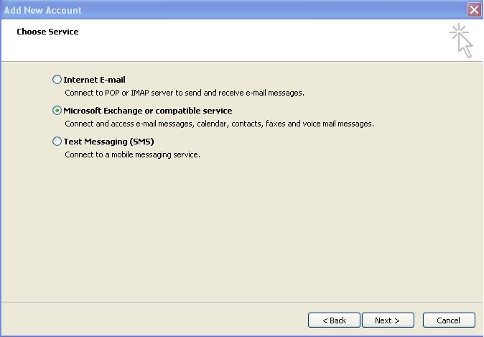

- Microsoft Exchange server: bos-exchange1.clintonhealthaccess.org
Make sure that the ‘Use Cached Exchange Mode’ box is checked.
User Name: Enter your full mail-id name, Example (psharma@clintonhealthaccess.org). Then click ‘More Settings’.

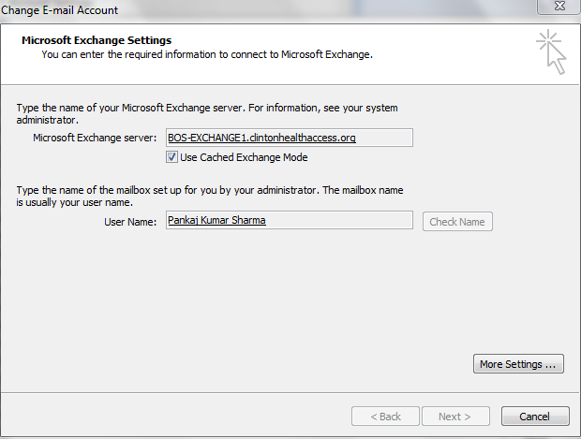

Note: If an error box pops up, click OK until you get to the “Microsoft Exchange” window.

- Click the ‘Connection’ tab.
Check the box ‘Connect to Microsoft Exchange using HTTP’.
Click ‘Exchange Proxy Settings…’

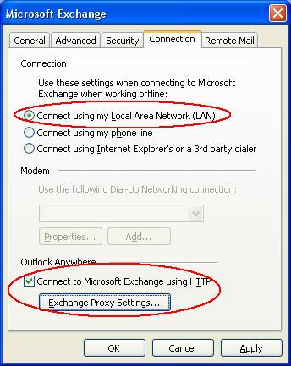

- The URL is mail.clintonhealthaccess.org
Check the box ‘Only connect to Proxy servers…’
- Type ‘msstd:mail.clintonhealthaccess.org
Check the box ‘On fast networks…’
Choose ‘Basic Authentication’ from the drop-down menu

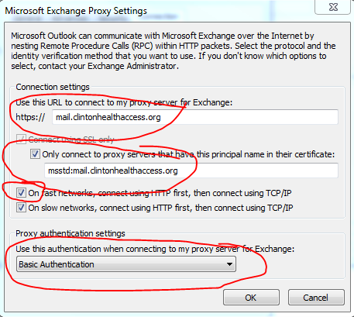

- Click OK, OK, and then ‘Check Name’ to make sure that your username is recognized. It will now prompt you for your login details.
Enter your credentials in the following format:

Login: <your full email address> (ex. “psharma@clintonhealthaccess.org”>
Password: <your password>
Or

clintonhealthaccess.org\ psharma@clintonhealthaccess.org
<Your Password>

Your username should now be underlined. Click ‘Next’ and then ‘Finish’.

